**\*This is a template with guidelines of contribution for the IGS Technical Report 2024. Please change only the blue-colored ones and do not change the black-colored ones. (Please delete these first three lines after you read them.)**

**NAME OF CENTER/GROUP/PROJECT**

**Technical Report 2024**

N. AUTHORa1, N. AUTHORb2, and N. AUTHORc3

1 INSTITUTION NAME OF AUTHORa, POSTAL ADDRESS OF INSTITUTION

E-mail: [your@email.address](mailto:your@email.address)

Phone: +NU-M-B-ER (**OPTIONAL**)

2 INSTITUTION NAME OF AUTHORb

3 INSTITUTION NAME OF AUTHORc

# Introduction

The annual Technical Report of the International GNSS Service (IGS, see Johnston et al., 2017) has been published successfully every year since its publication was resumed in 2011. The published IGS Technical Reports are available online at the IGS website. We appreciate your interest and valuable contributions to the report again. The next report, IGS Technical Report 2024, is scheduled to be published at the beginning of 2025.

In agreement with the previous IGS Technical Reports, the issue for 2024 must contain contributions from the main components of the IGS, namely global analysis centers (ultra rapid, rapid and final products), the global data centers, the working groups, and the pilot projects. Contributions from associated analysis centers, regional data centers, and other IGS related organizations are also welcome. Table 1 shows an overview of expected submissions.

The format of manuscript is the same as that for the IGS Technical Report 2023. Please pay close attention to the following general points:

* The page-limit of the contribution is “**6 pages**”.
* You can submit your contribution in doc/docx (**MS Word**), **LATEX**, plain text. Your contribution will be converted into LATEX format for final publication. If you want to write your contribution in LATEX, please refer to <http://www.igstr.aiub.unibe.ch/guideline.pdf>. A template for LATEX user is also available at the webpage <http://www.igstr.aiub.unibe.ch>.
* Please send your contribution to [**igs_tr@aiub.unibe.ch**](mailto:igs_tr@aiub.unibe.ch) until **January 31, 2025.**
* Please send your **figures** inside your contribution **separately** in a **vector-image format** such as **PDF, PS, or EPS**.

# Examples of table, figure, citation, and equation

## Table example

Please write caption of a table on top of the table contents.

Table 1: Expected contributions for the IGS Technical Report 2024.

|  |  |
| --- | --- |
| **Introduction, IGS general** | **required** |
| Governing Board | yes |
| Central Bureau | yes |
| Additional introductory/general reports | no |
| **Analysis Centers** | **required** |
| Analysis Center Coordinator  Center for Orbit Determination in Europe  European Space Operations Center  GeoForschungsZentrum  Groupe de Recherche de Géodésie Spatiale  JAXA/GSI  Jet Propulsion Laboratory  Massachusetts Institute of Technology  National Geodetic Survey  Natural Resources Canada  Scripps Institution of Oceanography  U.S. Naval Observatory  Wuhan University  Additional (associated) analysis center related reports | yes  yes  yes  yes  yes  yes  yes  yes  yes  yes  yes  yes  yes  no |
| **Data Centers** | **required** |
| Infrastructure Committee | Yes |
| Crustal Dynamics Data Information System  GSSC Global Data Center  Institut Géographique National  Korean Astronomy and Space Science Institute  Scripps Institution of Oceanography  Wuhan University  Additional data center related reports | yes  yes  yes  yes  yes  yes  no |
| **Working Groups, Pilot Projects** | **required** |
| Antenna  Bias and Calibration  Clock Products  GNSS Monitoring  Ionosphere  Multi–GNSS  Reference Frame  Real–Time  RINEX  Troposphere  Additional working group/pilot project related reports | yes  yes  yes  yes  yes  yes  yes  yes  yes  yes  no |
|  |  |
| **Other Contributions** | **required** |
| Other contributions are welcome | no |
|  |  |

## Figure example

All figures must be provided in separate files either in PostScript format (eps, ps) or in Portable Document Format (pdf). The figures will appear in full color in the electronic version of the Technical Reports. Keep in mind, however, that the Technical Report may also be printed in gray scale. Please make sure that your figures are still readable when printed in gray scale. Figure 1 shows an example of figure.

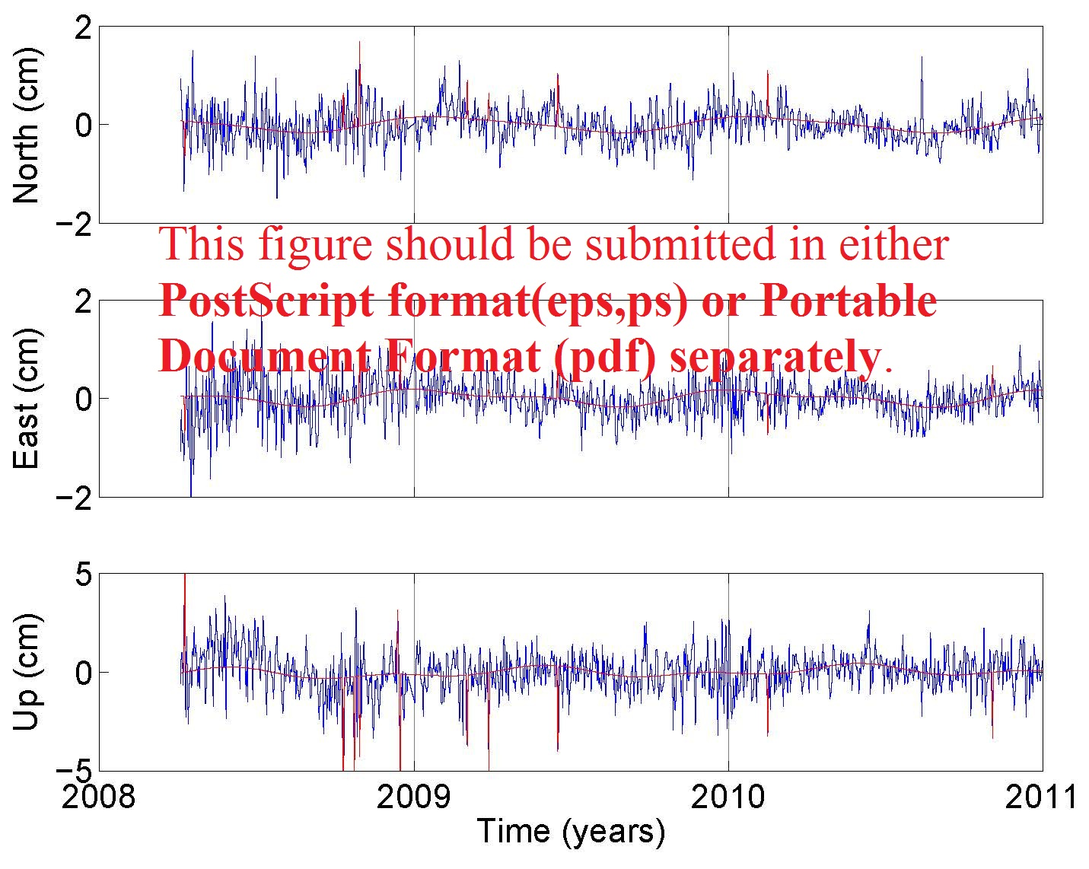

Figure 1: The title of figure. This figure **should be submitted in** either **PostScript format(eps,ps) or Portable Document Format (pdf) separately.**

## Citation example

Citations to bibliographic references should be in the author-year style such as (Author et al., yyyy). Examples are below in the reference section (Dach et al., 2009, Others et al. 2012).

## Equation example

The format of equation is



The equation can be numbered like above and referred like this sentence.

# Acknowledgement (if necessary)

We thank you for your contribution for the IGS Technical Report 2024.

# Reference

Authors. Title-of-Publication. Name-of-Journal/Book/Conference/URL, 00(0-0):000-000, Published-Year. Additional-Information-If-Necessary.

Dach, R., E. Brockmann, S. Schaer, G. Beutler, M. Meindl, L. Prange, H. Bock, A. Jäggi, and L. Ostini. GNSS Processing at CODE: Status Report. Journal of Geodesy, 83(3-4):353-366, 2009.

Dach, R., S. Schaer, S. Lutz, M. Meindl, H. Bock, E. Orliac, L. Prange, D. Thaller, L. Mervart, A. Jäggi, G. Beutler, E. Brockmann, D. Ineichen, A. Wiget, G. Weber, H. Habrich, J. Ihde, P. Steigenberger, and U. Hugentobler. CODE IGS Analysis Center Technical Report 2012. In R. Dach, and Y. Jean, editors, IGS 2012 Technical Reports, pages 35–46, 2013. IGS Central Bureau.

Johnston G, A. Riddell, G. Hausler. The International GNSS Service. In: Teunissen P, Montenbruck O (eds) Springer Handbook of Global Navigation Satellite Systems, Cham, Switzerland: Springer International Publishing, pp. 967–982, 2017, DOI: 10.1007/978-3-319-42928-1,